1. **A large retail company implements Power Apps, Microsoft Flow, and the Common Data Service. The board of directors is asking whether users are finding value in the technology. The company would like to measure and report usage of the software. You need to recommend a tool to determine software usage. What should you recommend?**

A. Microsoft Intune

B. Azure Stream Analytics

**C. Power Platform Analytics**

D. Dynamics 365 Product Insights

1. A company is building apps to support their business operations. The apps will use connectors to access data from several data sources and respond to a number of events generated by components. Which two operations can you use for connectors? Each correct answer presents part of the solution.

**A. Actions**

B. Plug-ins

C. Gateways

**D. Triggers**

3. A coworker is creating an app in Power Apps and needs to automatically synchronize data from an external source. The coworker is unable to locate a suitable Microsoft approved connector template in AppSource. You need to recommend a solution for the coworker. What should you recommend?

**A. Create a custom connector.**

B. Ask the outside source to send you the data once a week.

C. Use Power Automate to connect to the database.

D. Open a ticket with Microsoft and request a new connector.

E. Use Microsoft Azure Service Bus

A toy company creates a text classification model in Al Builder to monitor customer feedback for specific key words. When negative feedback is received for a toy, the company wants to proactively perform engineering reviews for the toy and schedule additional training sessions for workers who produce the toy. What are two possible ways to achieve the goal?

Each correct answer presents a complete solution.

A. Create a canvas app.

B. Implement the Virtual Agent.

C. Build a Power Automate flow.

D. Use the Common Data Model.

A company currently does not separate testing, development and production as per standard Application Lifecycle Management (ALM) protocol. The company uses Power Apps for accounting and sales processes. The company needs to use only one login account per user. The company also must prevent development and testing from impacting production. You need to implement a solution to meet the requirements. Which method should you select?

A. separate environments

B. separate tenants

C. separate Microsoft Azure Storage Blobs

D. separate connectors

A company is creating a canvas app to track and analyze customer visits to their retail stores. Data about customer visits is stored on- premises at each retail store location. The app must display data about customer visits when users launch the app. You need to ensure that the data is available for consumption by the app.

Which tool should you use?

A. Connector

B. Microsoft Dataverse

C. Data source

D. Power Automate

E. Data gateway

You need to implement Microsoft Business Applications along with the Microsoft Power platform.

Which three Microsoft products are part of the Power platform?

Each correct answer presents a complete solution.

A. Power Apps

B. Azure Active Directory

C. Power Automate

D. Azure Machine Learning

E. Power BI

You are a customer service manager. You need to implement a Power Apps portal that allows customers to submit cases. Which type of data source is used?

A. Dynamics 365 Connector

B. Microsoft SharePoint

C. Microsoft Azure Storage

D. Common Data Service

A company uses Dynamics 365 Sales. The company uses a browser-based app named Sales Hub. You need to ensure that users can access data from mobile devices. Which app should users install?

A. Dynamics 365 Remote Assist

B. Dynamics 365 Finance

C. Dynamics 365 Business Central

D. Dynamics 365 for Phones

You need to display sales orders greater than a specific threshold in a Power BI report. What should you use?

A. filter

B. Power Query

C. Common Data Service

D. connector

A company uses Power Platform. You must ensure that users cannot share customer data with other users. You must also ensure that user cannot connect to data sources unless you grant the user explicit permissions to access a data source. You need to recommend solutions to meet the company's security requirements. Which two types of policies should you recommend?

A. Office cloud policies

B. Group Policy Objects

C. environment-level policies

D. tenant-level policies

E. preset security policies

You create a business rule on contact entity to enforce the requirement that users must enter either a telephone number, fax number, or an email when creating a new record. The company decides to remove fax number from the condition. You need to update the business rule. What are two ways of achieving the goal? Each correct answer presents a complete solution.

A. Save a copy of the rule and change the condition. Deactivate and delete the original rule.

B. Deactivate the business rule and change the condition.

C. Take a snapshot of the business rule and change the condition.

D. Change the condition and activate the change.

A company is evaluating ways that they can implement Al Builder.

For which two scenarios can you use Al Builder?

Each correct answer presents a complete solution.

A. Send emails to all users who subscribe to a service.

B. Synchronize data from an external database.

C. Collect data from several data sources and display a dashboard that shows trending data.

D. Interpret images and perform an action based on the image.

E. Detect patterns in data and predict outcomes.

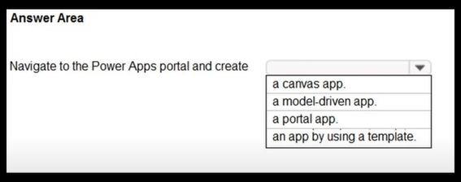

Answer (A model driven app)

You are a retail director for a large clothing company. Each week you use the corporate YouTube channel to create a video that highlights new initiatives, and goals for retail operations. You need to design a Power Apps app that streams the videos to internal users. Which objects should you use?

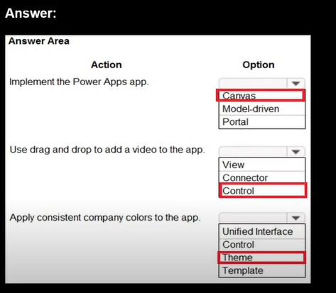

What is a benefit of deploying Microsoft 365 and Dynamics 365 apps in the same tenant?

A. Use Common Data Services to connect to application data.

B. You only need to set up groups in Microsoft 365 for permissions to all data.

C. Users can access both Microsoft 365 and Dynamics 365 by using Single Sign-on (SSO).

A company plans to use Al Builder to help improve business performance. You need to determine which Al Models are available for use.

Which three types of models can you use? Each correct answer presents a complete solution.

A. linear regression

B. prediction

C. object detection

D. anomaly detection

E. text classification

A company uses Dynamics 365 Supply Chain Management and Dynamics 365 Finance. User account data must be synchronized between the two systems. You need to ensure that the synchronized data is stored in one place. What should you use?

A. Azure IoT Central

B. Azure Active Directory

C. SQL Server

D. Microsoft Dataverse

A company plans to use Power Platform to build apps which address specific business challenges.

You need to recommend the appropriate types of Power Apps to use.

What should you recommend? To answer, select the appropriate option in the answer area.

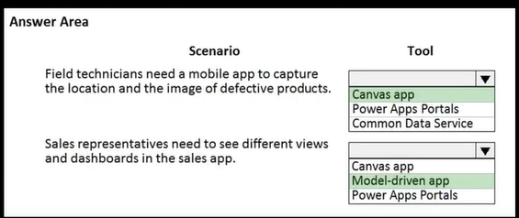

You need to create a Power Automate flow to allow managers to approve or deny vacation requests. Which two flow types should you use?

Each correct answer presents a complete solution.

Select all answers that apply.

A. Desktop flow

B. Business process flow

C. Cloud flow

D. Flow template

A company has locations in multiple regions. The company develops solutions based on Power Apps and Power Automate. You need to recommend features to support the implementation. Which Power Platform features should you recommend?

To answer, drag the appropriate features to the correct requirements. Each feature may be used once, more than once, or not at all. You may need to drag the split bar between panes or scroll to view content.

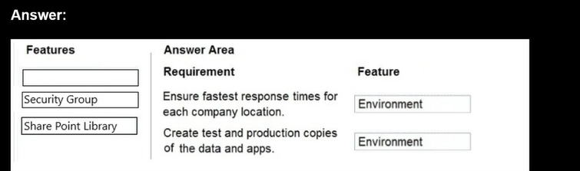

A company uses Microsoft 365 and Dynamics 365 Sales. The company does not have any developers on its staff. You need to explain to the executives the benefits of using Power Platform apps.

What are two benefits?

A. Users can send emails from Dynamics 365 Sales to their personal email addresses.

B. Users can create Power Apps to create apps for different departments.

C. Users can use Power Automate to share information between Microsoft 365 and Dynamics 365 Sales.

D. The company can unify all the mobile devices to one vendor.

HOTSPOT -

A company is evaluating ways to connect Power Platform apps to external services to perform complex activities. For each of the following statements, select Yes if the statement is true. Otherwise, select No.

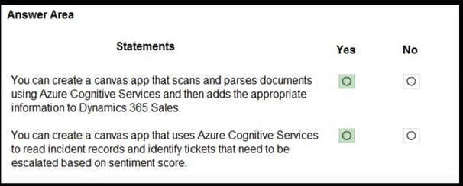

A company plans to implement Power Platform apps. The company does not plan to use any development tools or plug-ins. Which actions can you perform?

For each of the following statements, select Yes if the statement is true. Otherwise, select No.

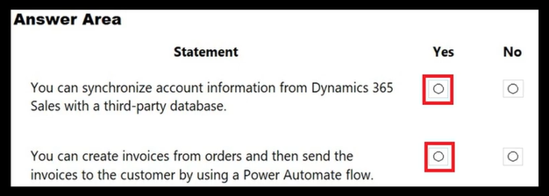

You create a Power Virtual Agents chatbot. You need to share the bot with other team members so that they can try out the bot before you share the bot with customers.

What should you use?

A. demo website

B. live production website

C. test chat feature

DRAG DROP

A travel company plans to use the Power Platform to create tools that help travel agents book customer travel. You need to recommend solutions for the company.

What should you recommend?

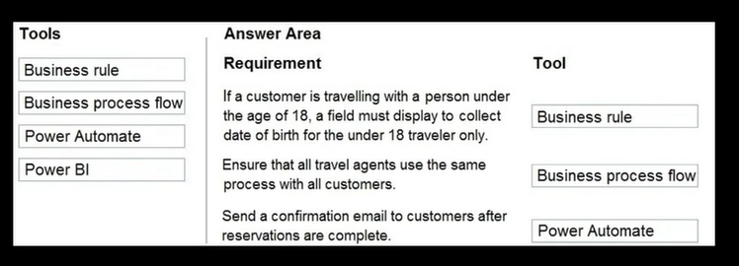

DRAG DROP

You need to explain the major components of the Common Data Model (CDM) and their functions. Match each term to its definition.

Instructions: To answer, drag the appropriate term from the column on the left to its definition on the right Each term may be used once, more than once, or not at all. Each correct match is worth one point.

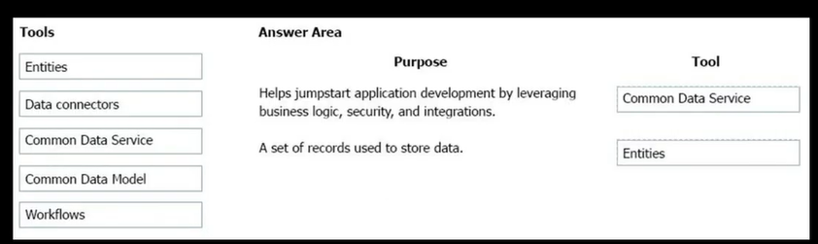

HOTSPOT

A company is evaluating Power Platform and has questions about the role that Microsoft Dataverse plays in using Power Apps and Power Automate. For each of the following statements, select Yes if the statement is true. Otherwise, select No.

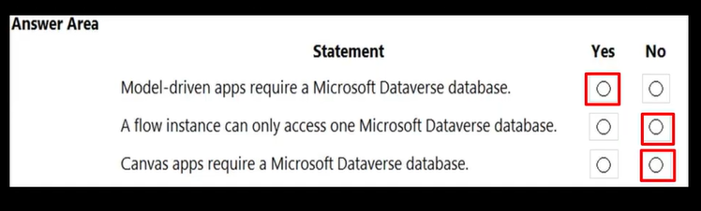

You are a sales manager for a large retail organization. You are creating a Power Apps app that will display customer product purchase information from your old point-of-sale (POS) system and need to link those sales to the customer accounts and product sales in Dynamics 365 Commerce. You need to use the appropriate component. What should you use?

A. Microsoft Dataverse

B. business process flow

C. entity metadata

D. business rule

DRAG DROP -

A manufacturing company is evaluating Al Builder. You need to select Al Builder models to address specified requirements. Which model types should you use?

To answer, drag the appropriate model types to the correct requirements.

Each model type may be used once, more than once, or not at all.

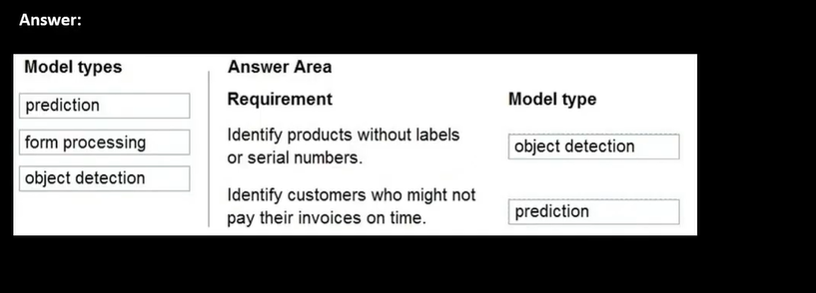

A company uses Dynamics 365 Sales. The company uses a browser-based app named Sales Hub. You need to ensure that users can access data from mobile devices. Which app should users install?

A. Dynamics 365 Remote Assist

B. Dynamics 365 Finance

C. Dynamics 365 Business Central

D. Dynamics 365 for Phones

A distribution company has multiple warehouses. Tax rates charged on sales orders need to be calculated based on locality and region. You need to recommend a cost-effective solution that can be implemented quickly.

What should you recommend?

A. Check AppSource for a tax add-on.

B. Create alerts in Dynamics 365 Finance for tax table changes.

C. Implement the Common Data Model.

D. Run a Power BI report.

E. Write scripts and code tax updates.

HOTSPOT -

You are building Power Apps that use both Dynamics 365 Sales and Microsoft 365.

For each of the following statements, select Yes if the statement is true. Otherwise, select No.

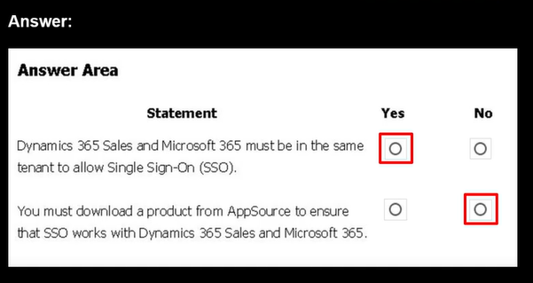

HOTSPOT -

You have version 1.0.0.0 of a published Power Apps app. You create and publish version 2.0.0.0 of the app. A customer goes through the process of restoring the previous version of the app.

How many versions of the app are displayed in the Version tab for the app?

To answer, select the appropriate option in the answer area.

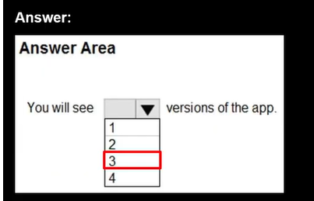

HOTSPOT -

An organization plans to create Power Platform solutions and is evaluating Microsoft Dataverse.

Instructions: For each of the following statements, select Yes if the statement is true. Otherwise, select No.

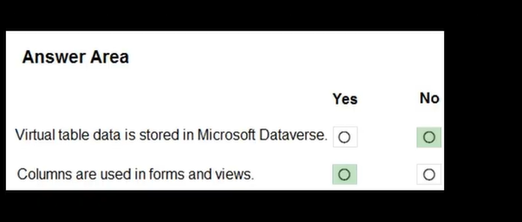

You are a sales representative. You create a Power BI report to visualize data from a Microsoft Excel workbook. Users need to be able to view and share the report.

Which two actions should you perform?

A. Pin the report to a dashboard.

B. Export the data.

C. Publish the dashboard.

D. Share the dashboard.

DRAG DROP

You manage the support team at a rapidly growing company. Customers and support technicians need a better experience when logging and responding to support requests. You need more visibility into what the support technicians are doing every week. You need to recommend tools to help the company's needs. Which tools should you recommend?

To answer, drag the appropriate tools to the correct requirements.

Each tool may be used once, more than once, or not at all.

You may need to drag the split bar between panes or scroll to view content.

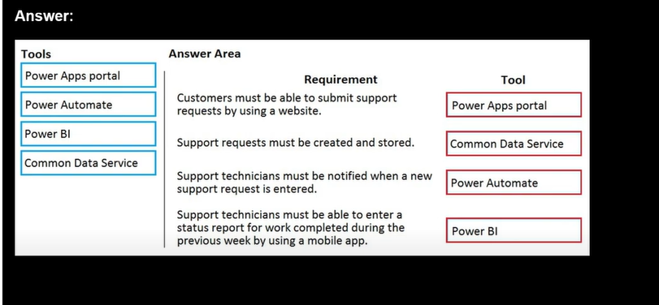

HOTSPOT -

A company is evaluating Al Builder.

Instructions: For each of the following statements, select Yes if the statement is true. Otherwise, select No.

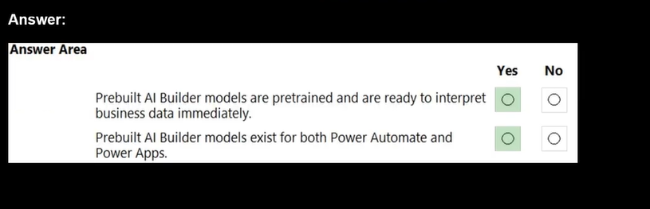

HOTSPOT -

You create a user-owned custom entity by using Common Data Service.

For each of the following statements, select Yes if the statement is true. Otherwise, select No.

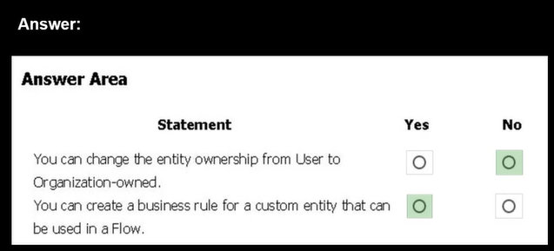

You have a Power Automate flow that fetches a list of contacts from Microsoft Dataverse.

You need to loop through contact collection and perform operations on each record.

Which connector should you use?

A. Data Operation

B. Control

C. Content Conversion

D. Microsoft Dataverse

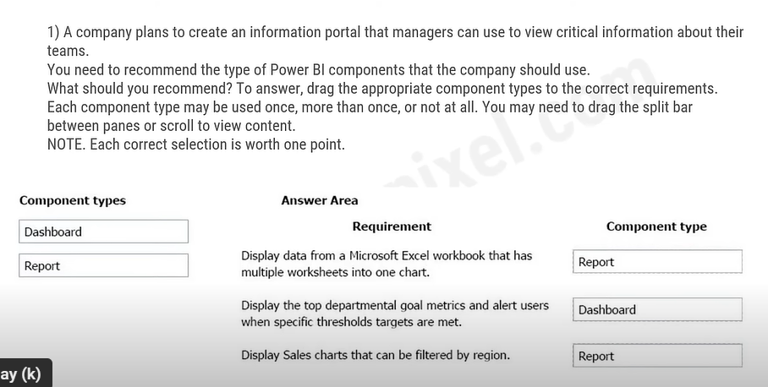

3) A developer is comparing the Power Apps model-driven approach and canvas apps approach for app solutions.

Which choices are the benefits of a model-driven Power App approach? (Choose 3 answers)

A. The user interface is consistent for both desktop and mobile users.

B. The no-code layout is consistent across all apps in the organization.

C. The app's rendering will automatically respond to the user's device.

D. Supports extensive Ul design flexibility and customization

4) You need to display sales orders greater than a specific threshold in a Power BI report.

What should you use?

A. filter

B. Power Query

C. Common Data Service

D. connector

5) A system administrator would like to view analytic reports that show relationships between the number of times an app has been used and how many times that same app has been shared.

Which administrator analytic report should the administrator use?

A. A usage report

B. A location report

C. A service performance report

D. A connectors report

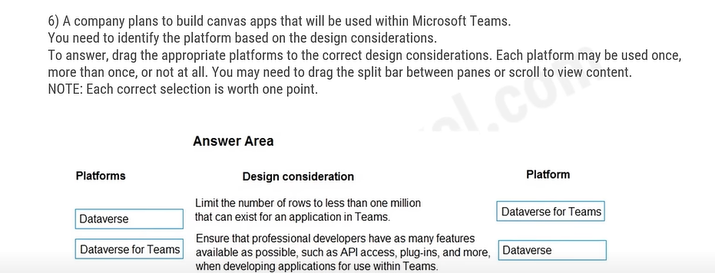

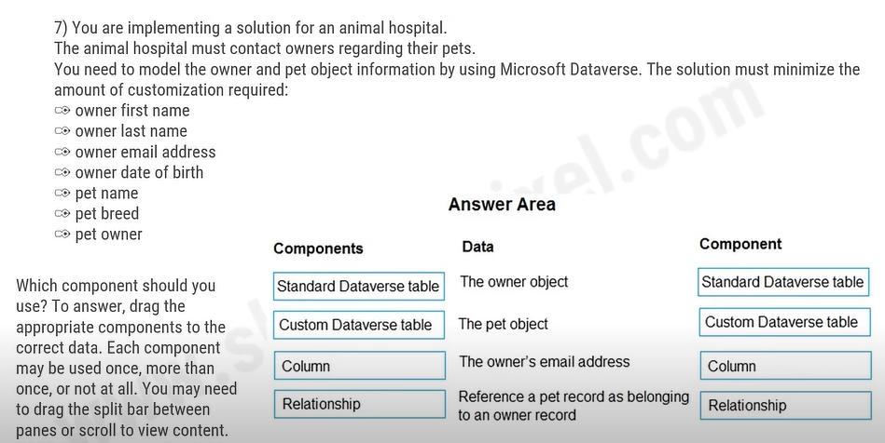

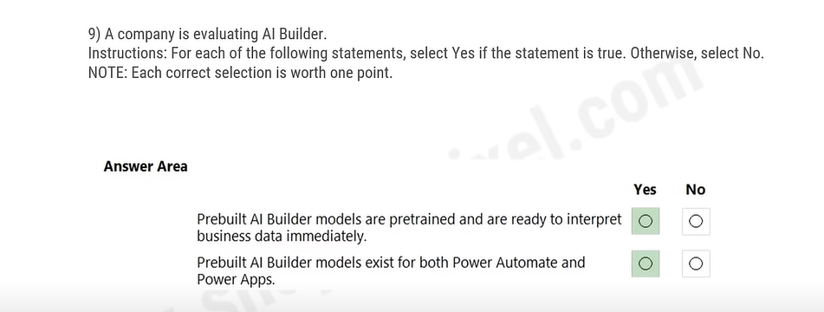

10) A data administrator wants to efficiently pull data for his Power Apps. The admin's primary concern is that the user interface displays text in a particular way.

Which Ul control should the data administrator select to display text from a single row of connected data?

A. Form

B. Gallery

C. Data card

D. Label

11) A coworker is creating an app in Power Apps and needs to automatically synchronize data from an external source. The coworker is unable to locate a suitable Microsoft approved connector template in AppSource.

You need to recommend a solution for the coworker.

What should you recommend?

A. Create a custom connector.

B. Ask the outside source to send you the data once a week.

C. Use Power Automate to connect to the database.

D. Open a ticket with Microsoft and request a new connector.

E. Use Microsoft Azure Service Bus.

12) In Power BI________are ideal for when you need to display frequently used or important filters on the report canvas for quicker access and eliminate the need to open a drop-down list to view the current filter state.

A. Q&A Visuals

B. slicers

C. Top N analyses

D. statistical summaries

13) A data analyst wants to use Power BI's data visualization features to discover relationships between different quarterly targets within his organization. Which data visualization method should the analyst use to check whether one measure meets a target defined by another measure?

A. A combo chart

B. A decomposition tree

C. A funnel chart

D. A gauge chart

14) You create a copilot studio chatbot.

You need to share the bot with other team members so that they can try out the bot before you share the bot with customers. the

What should you use?

A. demo website

B. live production website

C. test chat feature

15) A developer is trying to build a Power Automate flow, but it's currently broken. The developer has placed actions that pull data from Dropbox before an action that emails team members the Dropbox data. What step does the developer need to complete to make his Power Automate flow functional?

A. Move the action that uses Dropbox outputs after the email action.

B. Create a new flow.

C. Trigger the flow from a different point.

D. Place the action that uses Dropbox outputs before the email action.

16) You are a sales manager for a large retail organization. You are creating a Power Apps app that will display customer product purchase information from your old point-of-sale (POS) system and need to link those sales to the customer accounts and product sales in Dynamics 365 Commerce. You need to use the appropriate component. What should you use?

A. Microsoft Dataverse

B. business process flow

C. entity metadata

D. business rule

17) A developer is exploring the available PowerApps inside the AppSource library and has identified a few different marketing apps that may be useful. The developer wants to be able to test them with users on his team. Which AppSource app listing action allows for a testing simulation with real users and data?   
A. Free Trial   
B. Test Drive   
C. Get it Now   
D. Contact Me  
  
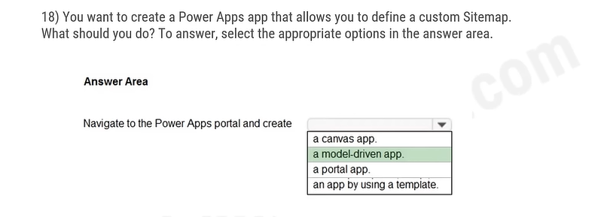

19) A developer is creating a model-driven app, but is unclear on which objects are most relevant to his connected data. Which objects should the developer create to only show the data connected to the form?

A. Main form

B. Charts

C. Workflows

D. Views  
  
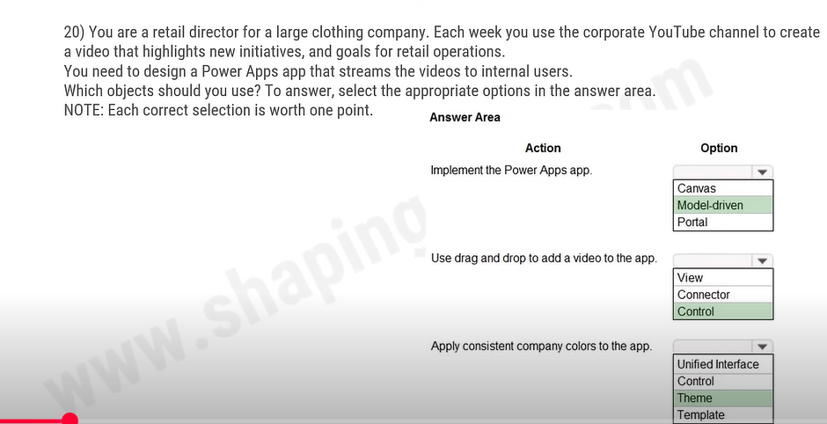

22) A Power Platform administrator is reviewing the various administrative tasks available and often confuses the admin centers when trying to track down specific tasks.

Which portal should the administrator access to view Power Automate audit logs?

A. Security and Compliance Center

B. Microsoft 365 Admin Center

C. Power Platform Admin Center

D. Microsoft Power Pages (formerly Power Apps Portal)

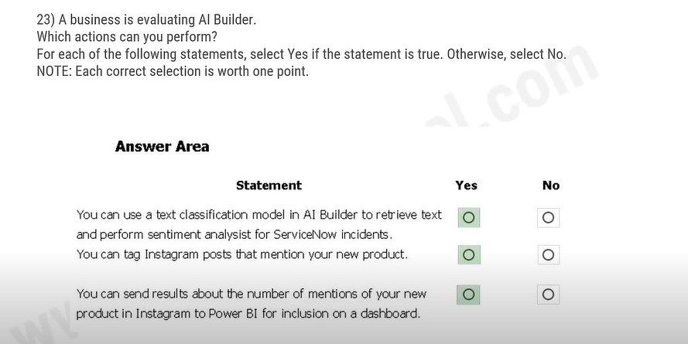

24) A developer wants to publish all of her new copilot studio chatbots at once but remembers there are limitations when publishing bots in new environments. How long after creating the first chatbot in a new environment can the developer create subsequent bots?

A. Up to 15 minutes

B. Up to an hour

C. Up to 24 hours

D. Immediately

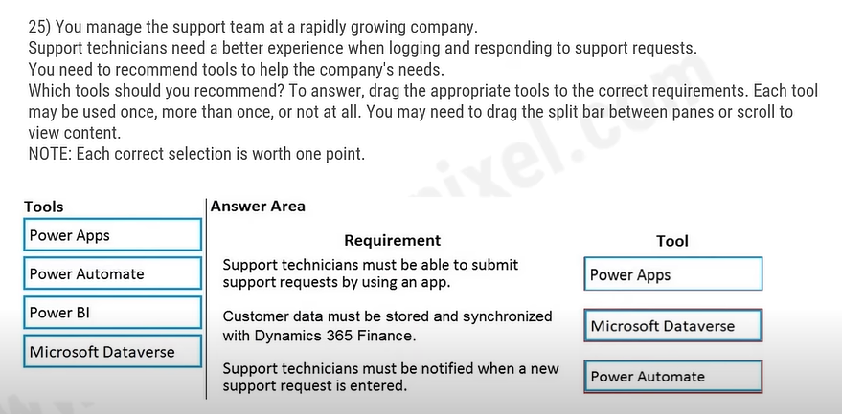

26) Which feature in Power BI's Al Insights tries to determine the language in which some text is written?

A. sentiment analysis

B. extract language

C. detect language

D. language analysis

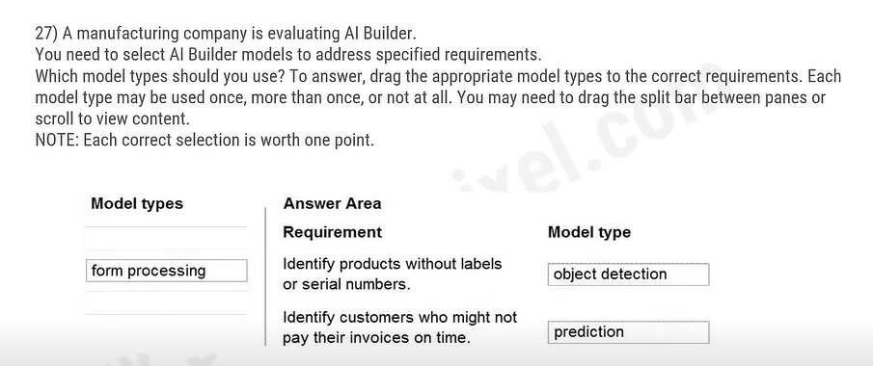

28) When a developer designing triggers in Power Automate wants to deploy an event-based trigger, which trigger type should the developer use?

A. A trigger for automated flows

B. A trigger for instant flows

C. A trigger for manual flows

D. A trigger for scheduled flows

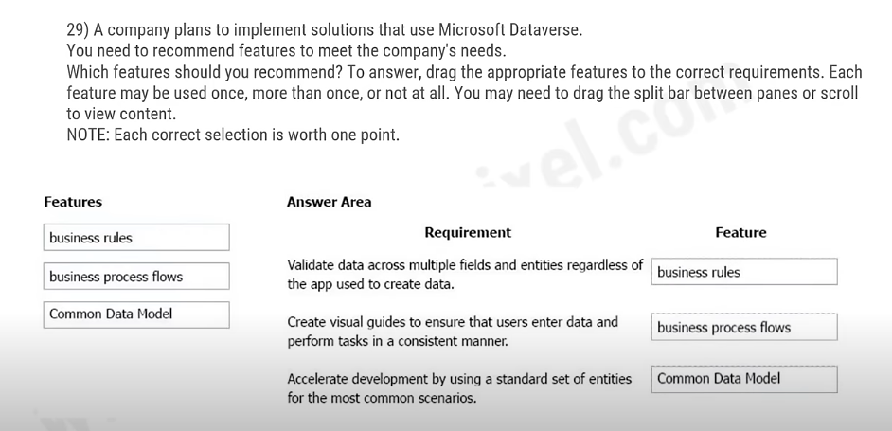

30) A developer is building conversation topics for Power Virtual Agent bots, and needs to identify opportunities in each conversation to obtain more detail using conditions.

Which conversation node allows the developer to add a condition?

A. Ask a question

B. Call an action

C. Show a message

D. Go to another topic

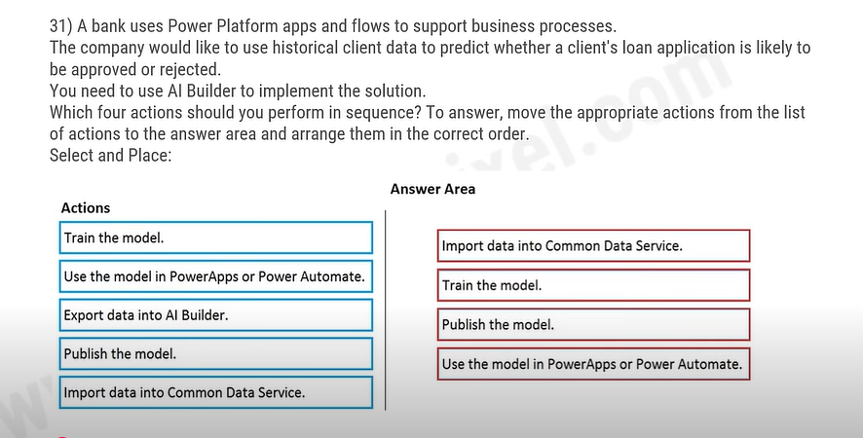

32) A data engineer is new to building Power BI sites and not familiar with the limitations of Report View, but he wants to learn before he publishes his site.

Which of the following tasks can the data engineer perform in Report View without publishing his Power BI site? (Choose 3 answers)

A. Copy and paste visuals between reports

B. Hide report pages

C. Change report visualization options

D. Pin reports and visualizations to a dashboard

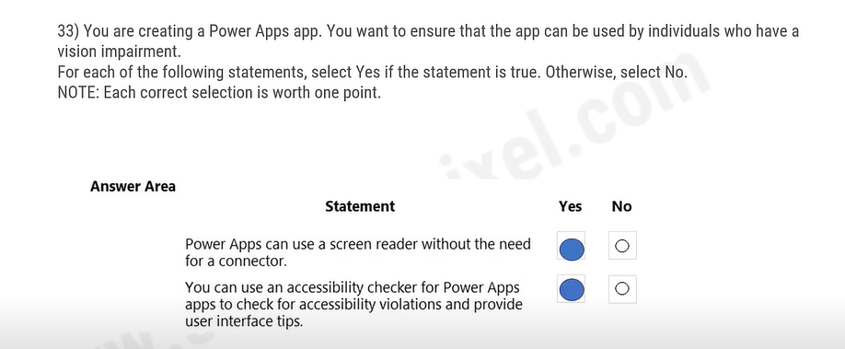

34) In Microsoft Power Apps, which type of application should you use when you want simple drag and drop functionality and the freedom to make your app look exactly how you want it to?

A. template

B. portal

C. canvas

D. model-driven

35) What is a benefit of deploying Microsoft 365 and Dynamics 365 apps in the same tenant?

A. Use Common Data Services to connect to application data.

B. You only need to set up groups in Microsoft 365 for permissions to all data.

C. Users can access both Microsoft 365 and Dynamics 365 by using Single Sign-on (SSO).

36) A data administrator is working with aggregates to combine values in reports in Power Bl, but he can't figure out why he doesn't have other function options available.

What is the most likely reason the data administrator's fields only have the "Count" function option available?

A. The field is actually a measure

B. The dataset owner has not classified the field as a number

C. The field has been dropped into a categorical bucket

D. The field is being used as an axis

37) A company uses Dynamics 365 Supply Chain Management and Dynamics 365 Finance.

User account data must be synchronized between the two systems.

You need to ensure that the synchronized data is stored in one place.

What should you use?

A. Azure IoT Central

B. Azure Active Directory

C. SQL Server

D. Microsoft Dataverse

38) A data analyst wants to use Power BI's analysis tools to help explain fluctuations in sales data between two quarters of the last financial year.

Which details should the analyst review to see actual changes in unit sales between the two quarters?

A. A 100% stacked column chart.

B. A scatter plot

C. The waterfall chart

D. The ribbon chart

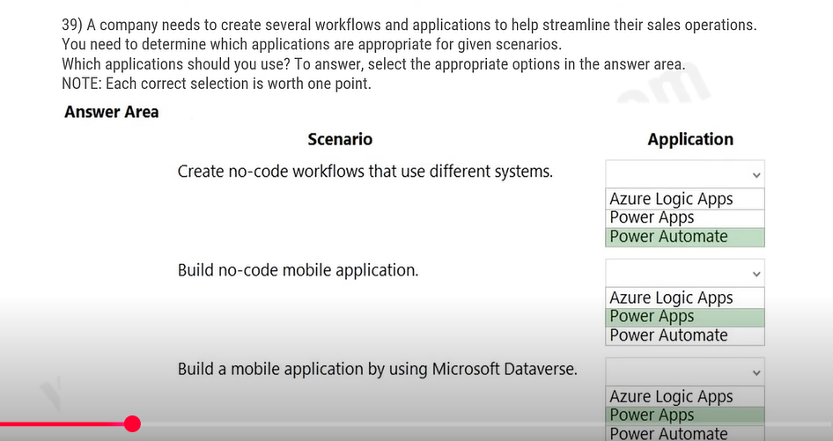

40) A security administrator is creating Power Apps security groups for the team and wants to ensure everyone one has the permissions required for their roles without making any compromises.

Which of the following is true about security groups within Power Apps?

A. Individual users can be assigned greater permissions than the group itself than

B. All users must have the same permissions level

C. Permissions in Power Apps carry over to Power BI

D. Power Apps security groups cannot share apps

41) A company uses Microsoft 365 and Dynamics 365 Sales. The company does not have any developers on its staff.

You need to explain to the executives the benefits of using Power Platform apps. What are two benefits? Each correct answer presents a complete solution.

A. Users can send emails from Dynamics 365 personal email addresses. Sales to their

B. Users can create Power Apps to create apps for different departments.

C. Users can use Power Automate to share information between Microsoft 365 and Dynamics 365 Sales.

D. The company can unify all the mobile devices to one vendor.

42) A developer is learning how to design a workflow using Power BI Desktop and Power BI SaaS service, but is trying to complete tasks that one of the two services cannot support.

Which of the following tasks can Lexy execute in both services?

A. Generating visualizations

B. Generating paginated reports

C. Creating modeling data

D. Creating apps and workspaces paces

43) A company plans to use Al Builder to help improve business performance.

You need to determine which Al Models are available for use.

Which three types of models can you use? Each correct answer presents a complete solution.

A. linear regression

B. prediction

C. object detection

D. anomaly detection

E. text classification

44) By utilizing ______, you can trigger Power BI data source refreshes based on source data changes and update the dataset using Power BI's API interface.

A. Power BI Desktop

B. PowerBl

C. ArcGIS

D. Microsoft Power Apps Flow

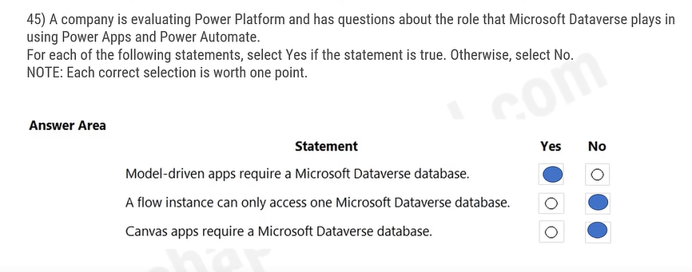

46) A data engineer is building different Power Automate flows and wants to give team members plenty of options, but the team requested a flow that can run with a simple click.

Which Power Automate flow type should the data engineer use to allow users to send automated messages with a mouse click?

A. Business process

B. Instant

C. Desktop

D. Scheduled

47) A company is evaluating ways that they can implement Al Builder.

For which two scenarios can you use Al Builder? Each correct answer presents a complete solution.

A. Send emails to all users who subscribe to a service.

B. Synchronize data from an external database.

C. Collect data from several data sources and display a dashboard that shows trending data.

D. Interpret images and perform an action based on the image.

E. Detect patterns in data and predict outcomes.

48) A data engineer has deployed a Finance and Operations environment and successfully integrated Microsoft Power Platform. He knows many ways to get his Power Platform apps to talk to the Finance and Operations apps and retrieve account information.

Which event type should the data engineer configure if the engineer wants local app data to be stored while overlapping data raised is kept in sync?

A. Dual-write event

B. Data event

C. Visual entities

D. Business event

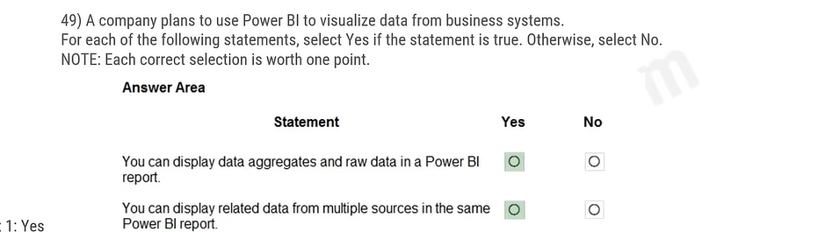

50) A systems administrator would like to use the Power Apps accessibility app checker to ensure her canvas apps are truly accessible. The administrator wants to use the checker to eliminate any potential problems. Which of the following can be checked in the accessibility app checker in Power Apps? (Choose 3

A. Errors

B. Warnings

C. Tips

D. Logs

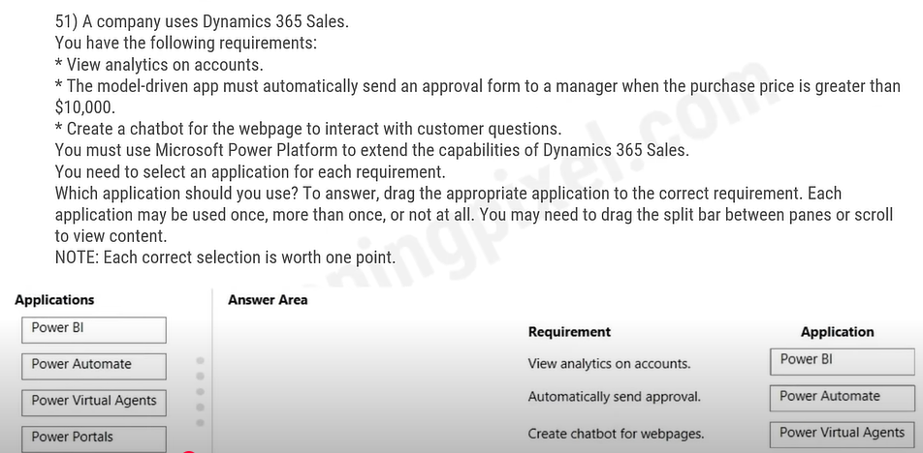

52) An IT manager needs to create and provision new production environments as a Power Platform administrator, but only holds a Microsoft 365 plan license.

Which plan allows users to provision a new production environment?

A. Dynamics 365 plans

B. Dynamics 365 Team plans

C. Dynamics 365 Trials

D. Power Apps Developer plans

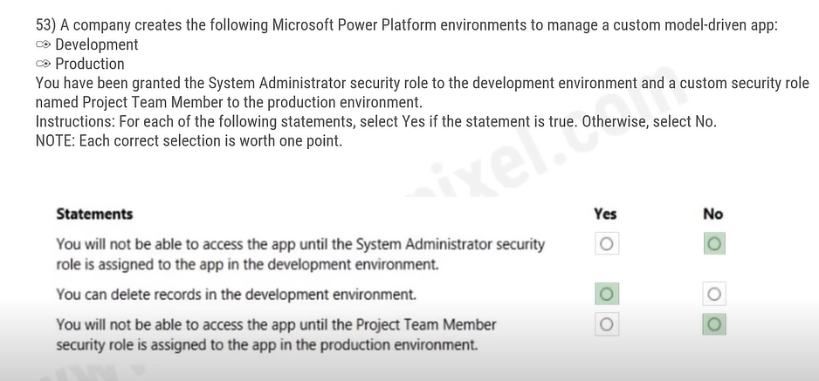

54) An administrator needs to be able to find personal views within the edit user interface. Which of the following statements is true about model-driven apps?

A. Personal views cannot be recreated.

B. System and public views cannot be based on personal view

C. Personal views are found above the system and public views.

D. Public views are not customizable.

55) A company currently does not separate testing, development and production as per standard Application Lifecycle Management (ALM) protocol. The company uses Power Apps for accounting and sales processes. The company needs to use only one login account per user. The company also must prevent development and testing from impacting production.

You need to implement a solution to meet the requirements.

Which method should you select?

A. separate environments

B. separate tenants

C. separate Microsoft Azure Storage Blobs

D. separate connectors

56) A system architect plans to deploy certain Power App apps to different user groups in his organization and wants to organize their update channels based on what is best for each end user. Which two are examples of Power Apps consuming data from a third-party app? (Choose

?(Choose 2 answers)

A. An employee-built app pulling data from Twitter.

B. An employee-built app exporting business data to Google Analytics.

C. An employee-built app syncing data with Dataverse.

D. An employee-built app exporting data from a Power Automate app.

57) A company is creating a canvas app to track and analyze customer visits to their retail stores. Data about customer visits is stored on-premises at each retail store location.

The app must display data about customer visits when users launch the app.

You need to ensure that the data is available for consumption by the app.

Which tool should you use?

A. Connector

B. Microsoft Dataverse

C. Data source

D. Power Automate

E. Data gateway

58) A developer is experimenting with Microsoft Power Apps and Azure Cognitive Services to design a better client experience. The developer would like to build an app to simplify the company's services. Which Azure Cognitive Service uses natural language understanding (NLU) to help users more fluidly interact with apps?

A. Cognitive Service for Decision

B. Cognitive Service for Vision

C. Cognitive Service for Language

D. Cognitive Service for Speech

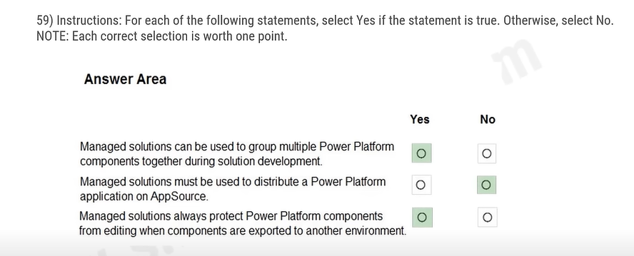

60) In Microsoft Power Apps, which type of application allows for creation of external-facing websites without needing to understand coding?

A. template

B. portal

C. canvas

D. model-driven

61) A company uses Power Platform.

You must ensure that users cannot share customer data with other users. You must also ensure that uses cannot connect to data sources unless you grant the user explicit permissions to access a data source.

You need to recommend solutions to meet the company's security requirements.

Which two types of policies should you recommend? Each correct answer presents presents part of the solution.

A. Office cloud policies

B. Group Policy Objects

C. environment-level policies

D. tenant-level policies

E. preset security policies

62) A data security administrator is reviewing the different connectors he can use to make data connections in Power Apps. He needs to ensure the connector he uses is secure and requires a user to enter a username and password.

Which of the following is the only secure connector that requires a username and and password?

A. Windows Authentication

**B. SQL username and password authentication**

C. Azure AD Integrated

D. Open-standard Authorizations (OAuth)

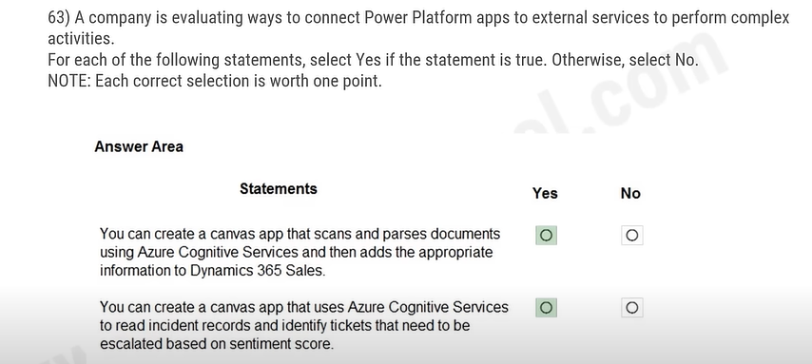

64) A company needs technicians in the field to access real-time diagnostic data from their smart devices. The company requires a flexible, customizable option for its team.

Which Power Platform service would be best for making company data easier to access in the field?

A. Power Automate

B. Power BI

C. copilot studio

D. Power Apps

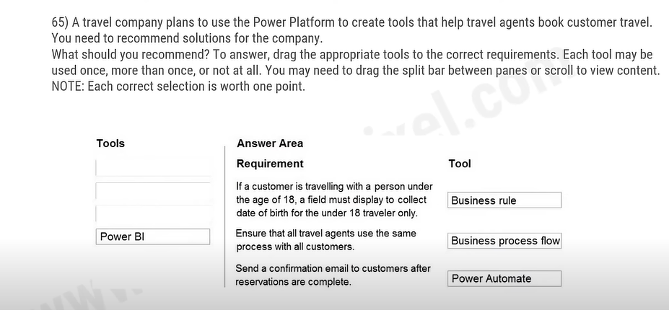

66) A developer is building multiple desktop flows with Power Automate, and many flows involve repeating large sets of tasks.

Which loop action should the developer use to repeatedly iterate a block of actions?

A. Exit loop

B. Loop condition

C. Next loop

D. For each

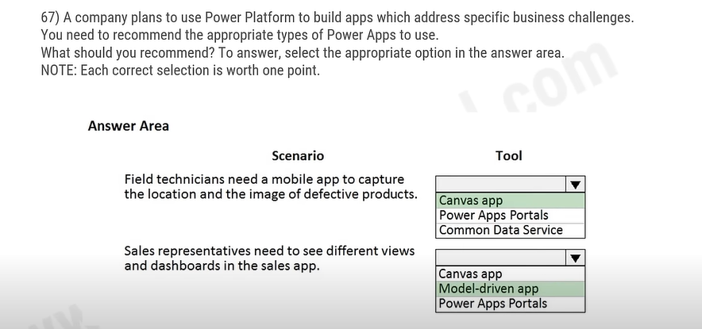

68) A data administrator wants to configure end-user authentication for a chatbot he created in his company's Teams. He would like the Teams chatbots to be able to silently sign the user in. Which authentication fields must be provided to enable single sign-on (SSO)?

A. Client secret

B. Token exchange URL

C. Token URL template

D. Scope list delimiter

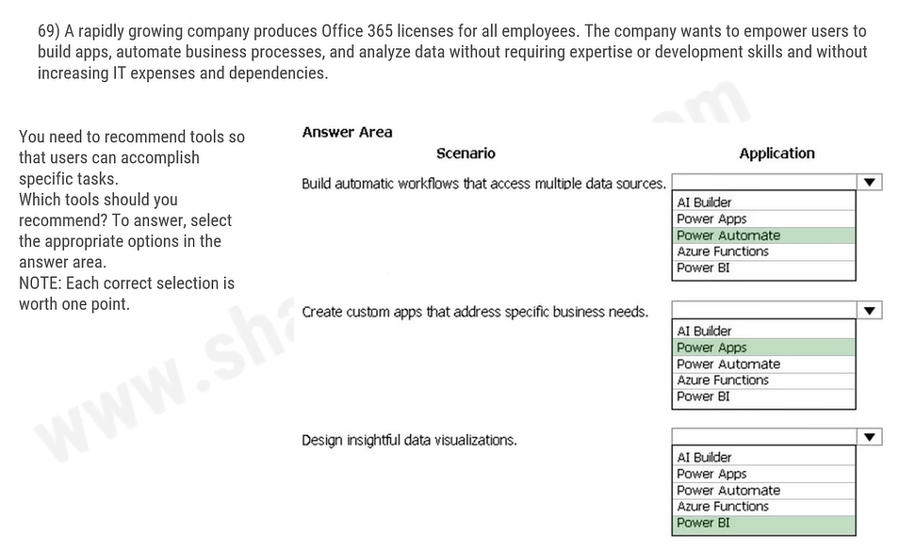

70) A data engineeer is configuring Power Automate data operations, and wants to save strings of data for easy repetition while building a flow.

Which data operation will best address this specific need for the engineer?

A. Data Operation - Compose action

B. Data Operation - Join action

C. Data Operation - Select action

D. Data Operation - Filter array action

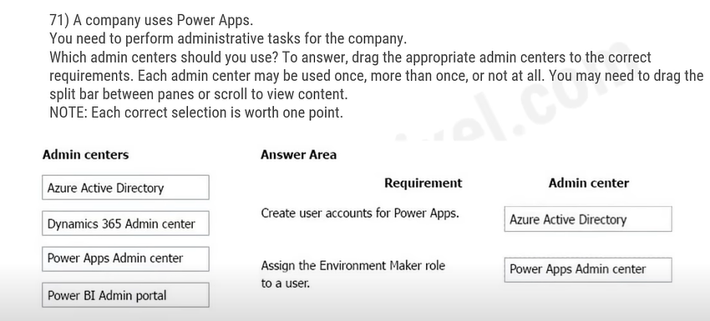

72) A team lead manages the release of a new app that the team built in Power BI and needs to review which promotion stages the app can go through before being released publicly.

Which stage in the app release management pane indicates the app is now available for testing publicly?

A. Workspace

B. Testing

C. Pre-productions

D. Production

73) A large retail company implements Power Apps, Microsoft Flow, and the Common Data Service.

The board of directors is asking whether users are finding value in the technology. The company would like to measure and report usage of the software.

You need to recommend a tool to determine software usage.

What should you recommend?

A. Microsoft Intune

B. Azure Stream Analytics

C. Power Platform Analytics

D. Dynamics 365 Product Insights

74) A data engineer is working with data sources but needs to share the configured connections across her own work devices.

Which connection for a data source can be shared across devices or between users? (Choose 3 answers)

A. Collections

B. Tables

C. SQL Server

D. Dropbox

75) You need to implement Microsoft Business Applications along with the Microsoft Power platform. Which three Microsoft products are part of the Power platform? Each correct answer presents a complete solution.

A. Microsoft Power Apps

B. Azure Active Directory

C. Power Automate

D. Azure Machine Learning

E. Power Bl

76) A security administrator uses Power Automate to build out approval types allowing security team members to quickly approve timesheets and leave requests.

If the security team wants to require only a single person's review to grant a leave request, type is most efficient? request, which approval

A. Approve/Reject - First to respond

B. Approve/Reject - Everyone must approve

C. Custom responses - Wait for all responses

D. Custom responses - Wait for one response

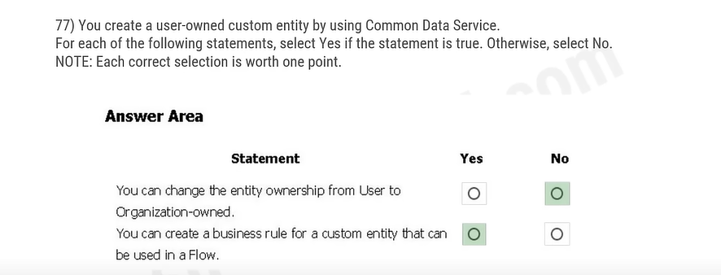

79) A company uses Dynamics 365 Sales. The company uses a browser-based app named Sales Hub. You need to ensure that users can access data from mobile devices.

Which app should users install?

A. Dynamics 365 Remote Assist

B. Dynamics 365 Finance

C. Dynamics 365 Business Central

D. Dynamics 365 for Phones

80) An administrator notices that weekly reports, monthly summaries and other recurring messages and emails are frequently late. The admin team is understaffed as the company rapidly expands, and needs an efficient way to manage these processes.

Which flow is ideal to efficiently automate these tasks that occur within a set period of time?

A. Branching flow

B. Scheduled flow

C. Instant flow

D. Automated flow

82) A data analyst discovers no connectors are available for the processes he'd like to automate at his organization. He would like to build a custom connector for website automation, but the analyst's experience in web development is limited to basic HTML and style sheets.

Which automation method would be best for the analyst to deploy?

A. Web browser automation

B. Custom connector

C. HTTP connector

D. Desktop application automation

83) You create a Power BI dashboard that displays data from Dynamics 365 Customer Engagement.

You need to share the Power BI dashboard with coworkers. What are three possible ways to achieve the goal? Each correct answer presents a complete solution.

A. Create a Power BI workspace and grant coworkers permissions.

B. Publish the dashboard as an app to your coworkers.

C. Export the data into Common Data Service for others to manipulate in Power BI.

D. Export the data to Microsoft Excel for coworkers to import and view in Power BI.

E. Embed reports in your company's internal web portal.

85) A recent update has been made to a canvas app.

The update causes usability issues. You need to roll back the app to a previous version. What should you do?

A. Restore the previous version of the app.

B. Uninstall the app for all users and reinstall by using the package from a previous version.

C. Deactivate the live app, import the previous version of the app, and then activate the app.

D. Delete the app and create a new app based on the previous version.

86) You are a district manager for a large retail organization. You train each store manager to use Power BI to track sales and daily sales targets.

A store manager remembers learning about the Analyze in Excel option but cannot find the option in their Power BI dashboard. You need to help the user resolve the issue. How should you advise the user?

A. Install the Power BI Desktop app.

B. Select the Spotlight button on the dashboard tile.

C. Subscribe to the dashboard and follow the email link.

D. Navigate to the report used by the dashboard.

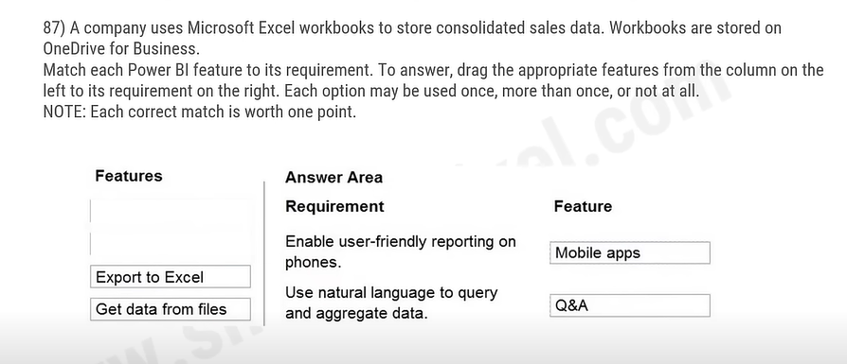

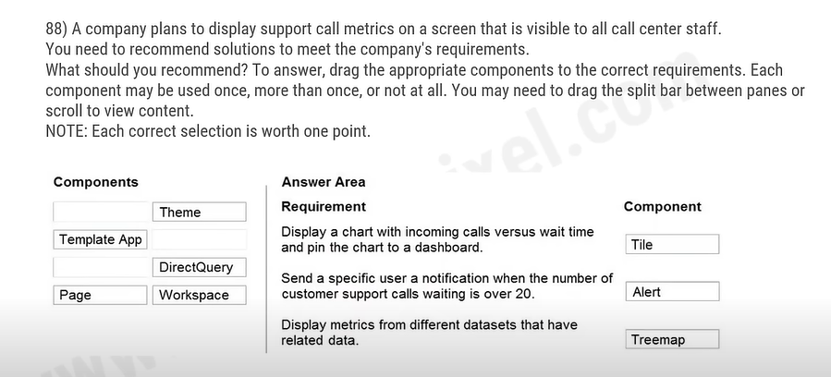

89) You create a Power BI dashboard that displays Common Data Model data.

You need to share the Power BI dashboard with coworkers and allow the coworkers to collaborate.

What are two possible ways to achieve the goal? Each correct answer presents a complete solution.

A. Create a Power Bl workspace and grant co-workers permissions. permissions.

B. Publish the dashboard as an app to your coworkers.

C. Export the data to Microsoft Excel. Make required changes and then re-import the data.

D. Create a Power Automate flow to export the data into a SQL Server database.

90) You are using Dynamics 365 Sales.

You need to create a Power BI report that includes customer office locations. The City and State columns must be combined to form one column on the report. What should you do?

A. Use Power Query Editor to merge columns.

B. Import the data.

C. Export data to Microsoft Excel.

D. Create a view.

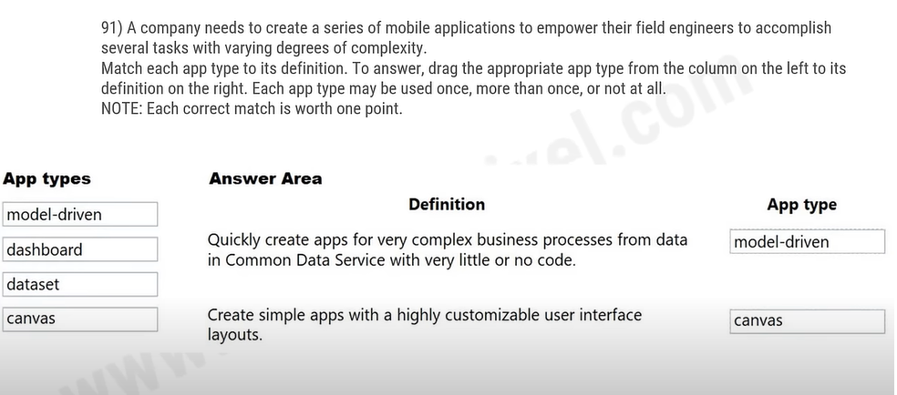

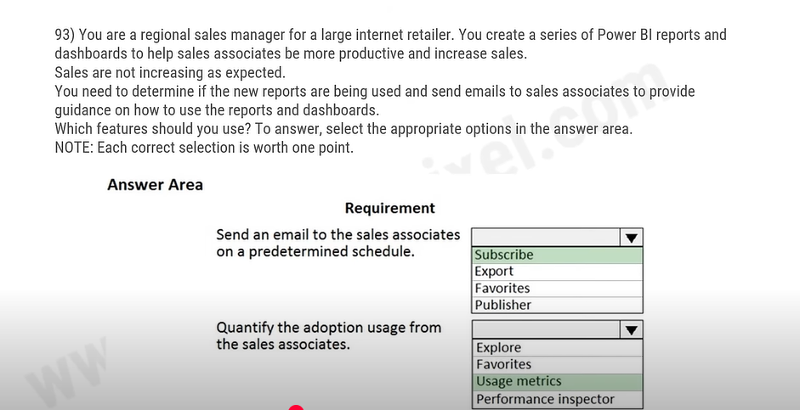

94) You are creating Power BI reports.

You need to choose which filters you can use for reports.

Which three types of filters can you use? Each correct answer presents a complete solution.

A. drill-down

B. automatic

C. database

D. manual

E. external

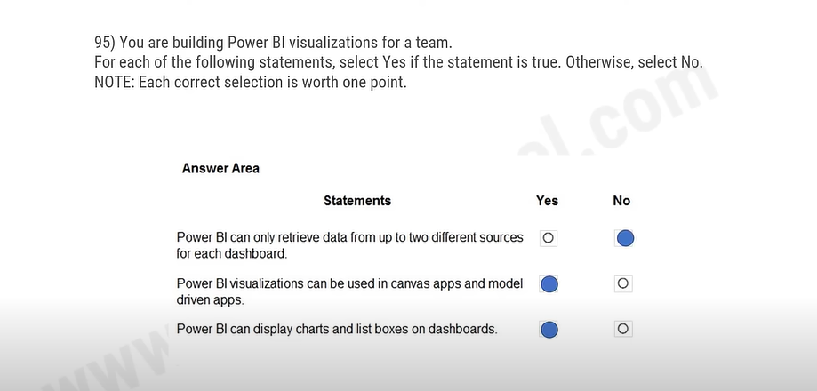

96) A manufacturing company uses Internet of Things (IoT) devices to monitor the temperature in different parts of their warehouse.

You need to view near real-time information from the lot devices in Power BI Service dashboards.

Which tool should you use?

A. Scheduled refresh dataset

B. Streaming dataset

C. Content Pack dataset

D. Power BI dataflows

E. Quick Insights

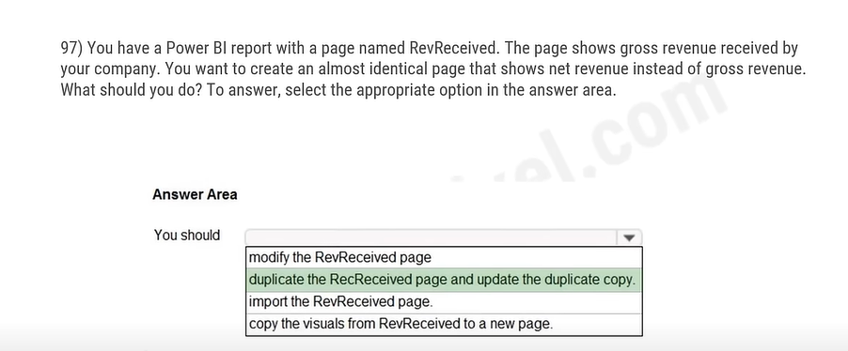

98) You create a set of dashboards and reports for a project team that combines data from different sources in Power BI. Some of the data is considered sensitive. You need to distribute the dashboards and reports securely to the team.

What should you create?

A. a custom data connector

B. a published app

C. a Microsoft flow

D. a Power BI workspace

99) You are creating visuals in Power BI.

You create area charts, pie charts, and donut charts that use your company's data.

You need to display the charts to others at the company.

Which two objects can you add the charts to? Each correct answer presents a complete solution.

A. Power BI service

B. Power BI reports

C. Power BI desktop

D. Power BI dashboards

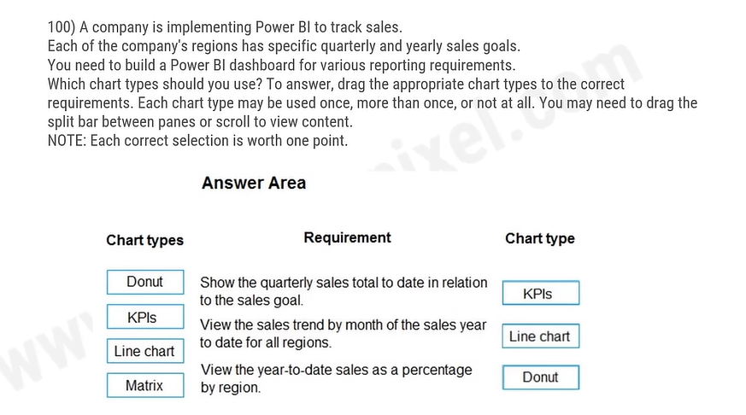

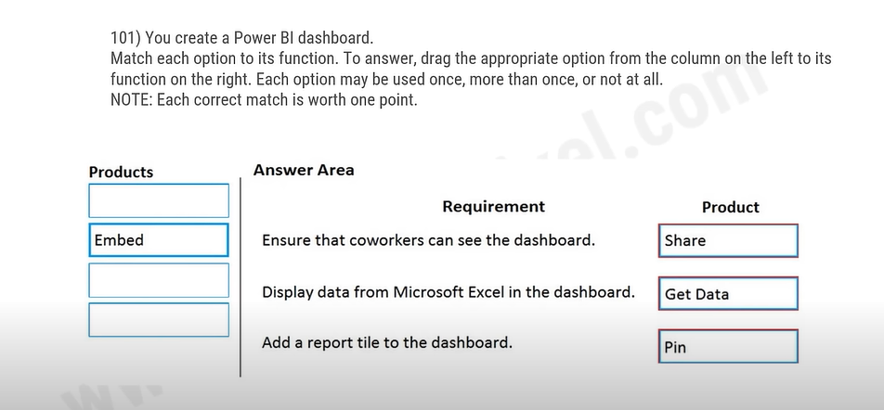

102) You are using Dynamics 365 Sales.

You need to pull data into a Power BI report for your team. The City and State columns must be combined to must be form one column on the report.

Which function would you use? Each correct answer presents a complete solution.

A. Use Power Query to merge column

B. Import the data.

C. Export data to Microsoft Excel.

D. Create a view.

103) A carpet cleaning company uses Dynamics 365 Sales.

The process for entering customer information during onsite sales calls is very complicated. The company wants a simplified screen that allows salespeople to capture the customer name, phone number, and other information while speaking to the customer. What should you recommend?

You need to recommend a solution that works on various types of mobile devices.

A. Microsoft Dataverse

B. Power Automate

C. Al Builder

D. Canvas app

E. Power BI

104) A company using Power Platform is implementing Power BI. The company plans to connect to several data sources and create reports and dashboards. You need to identify the data sources they can connect to. Which two data sources should you use? Each correct answer presents a complete solution.

NOTE: Each correct selection is worth one point.

A. Microsoft Excel

B. Microsoft Dataverse

C. Microsoft OneNote

D. Microsoft Word

105) You create a multi-page Power BI report for an organization.

You must enable salespeople in the organization to use the report to view data relevant to their sales region only. You need to enable security for the report. What should you use?

A. sensitivity labels

B. Microsoft Azure Active Directory

C. Microsoft Trust Centre

D. data loss prevention policies

E. row-level security

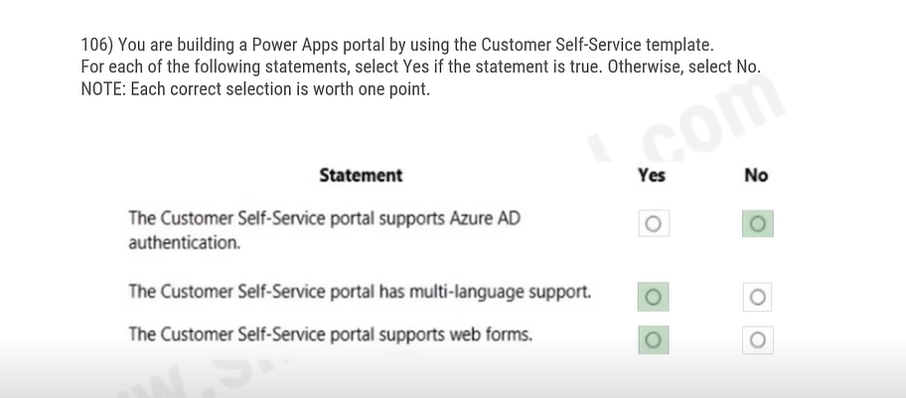

107) User1 creates several Power BI dashboards for a company. User1 shares a dashboard with User2 who works for another company. User2 reports that she is able to view the dashboard. User2 forwards the email containing the dashboard sharing link that she received to User3.

User3 reports that he receives an error message when he selects the link to view the dashboard. User3 can view a dashboard that he has created. You need to determine why User3 receives an error. What is the issue?

A. User3 is running an out-of-date version of Power Bl and must upgrade to a newer version.

B. User2 is signed in to the dashboard and must sign out before User3 can sign in.

C. Forwarding the email does not share the dashboard with User3.

D. User1 is signed in using the wrong organizational account for Power BI.

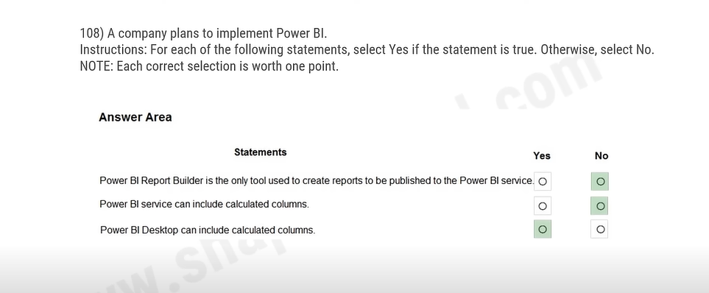

109) You are developing reports for a company. You must create visualizations that include the following data: Invoices due from a third-party enterprise resource planning (ERP) system Number of calls made to the client from Microsoft Dataverse Microsoft Excel file data The reports must be displayed in a single page. You need to create the visualizations. What should you use?

A. deployment pipelines

B. tables

C. columns

D. dashboards

110) You are using the Power BI service to view a visual on a report that has been shared with you. You need to add the visual to a dashboard as a tile. Which action should you perform?

A. Export data

B. Pin

C. Copy

D. Spotlight

111) A company manages a chain of retail stores. The company stores a list of retail store names and numbers in one Power BI table. The company stores sales transaction data including a transaction ID in another table. The transaction ID includes the store number. You need to show the store name for all retail transactions in all Power Bl reports. Which tool should you use?

A. Query Editor

B. Power BI Service

C. Microsoft Excel

D. Data Connector

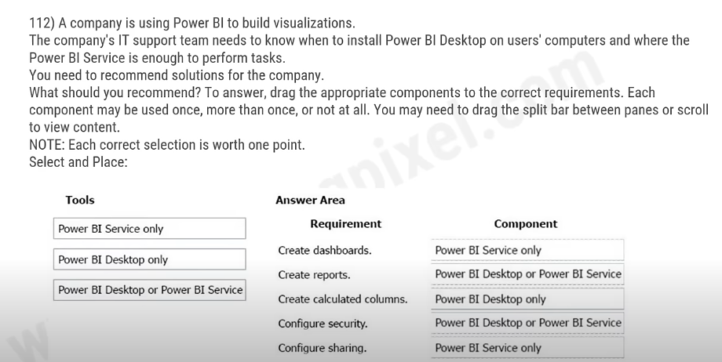

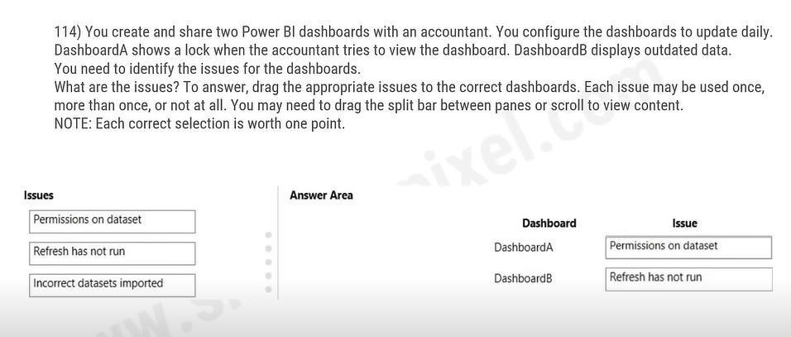

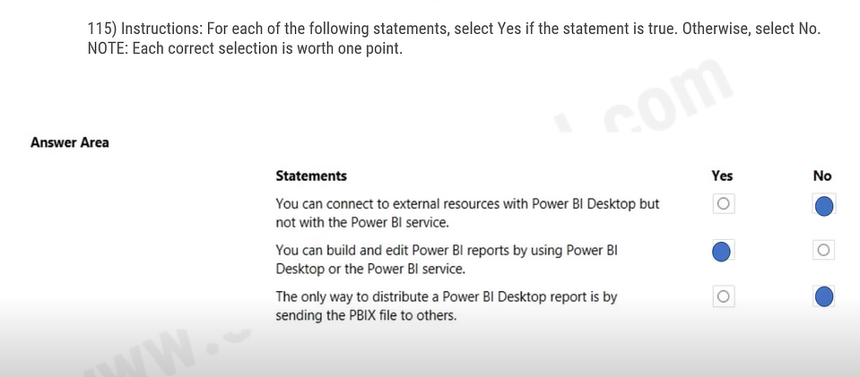

116) You create a Power App portal. When a user signs into the portal the following error displays: User not found You confirm that the user's sign in information is correct. You need to determine the cause of the error. What should you do?

A. Disable custom error messages.

B. Create a custom error message.

C. Enable diagnostic tools in Lifecycle Services cycle Services.

D. Enable Maintenance mode.

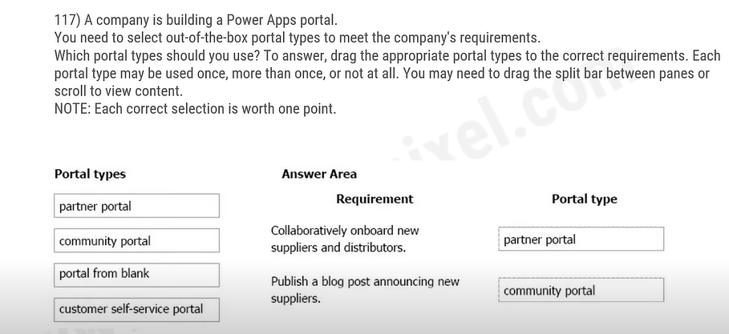

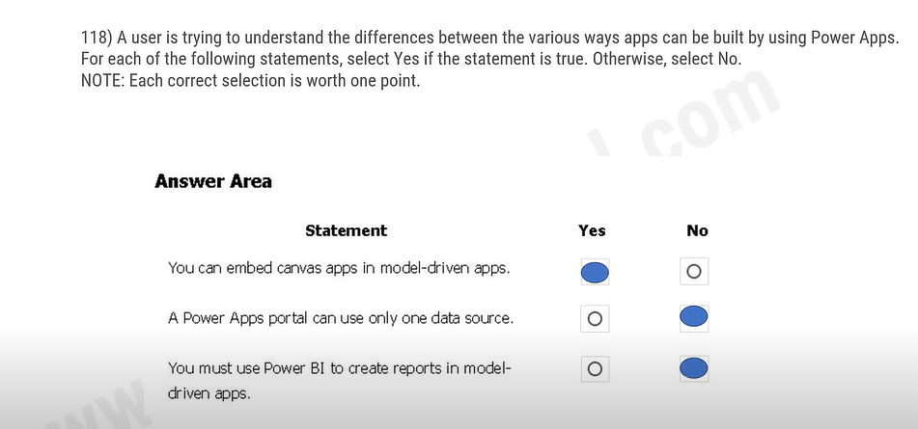

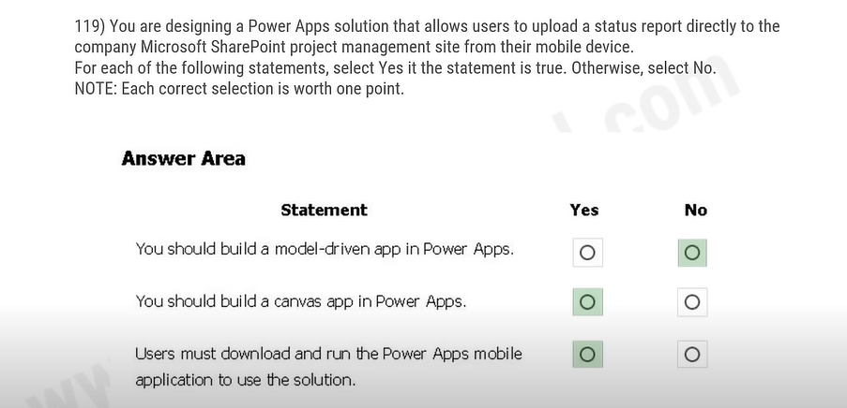

120) A company's customer-facing applications must comply with Global Data Protection Regulations (GDPR) regulations. You need to recommend actions to help ensure GDPR compliance. Which two features should the company use? Each correct answer presents part of the solution. NOTE: Each correct selection is worth one point.

A. Force a user to update security questions after a specific amount of time.

B. Prompt a user for consent to use their personal data and record the date consented.

C. Block users who are identified as minors.

D. Automatically deactivate a user who has not used the portal in six months.

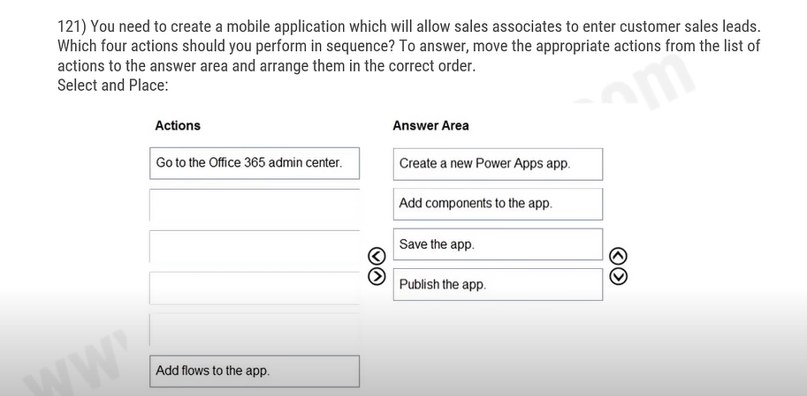

122) A company uses Power Apps canvas apps. When a user opens Power Apps Studio in a browser and selects Apps I can edit, they do not see an app that they need to modify. You need to determine why the user cannot see the app. What are three possible reasons? Each correct answer presents a complete solution.

A. The user selected an incorrect Power Apps environment.

B. The user has not been granted the System Customizer role.

C. The user has not been set as the app co-owner.

D. The app has not been shared with the user.

E. The environment does not have a Microsoft Dataverse database.

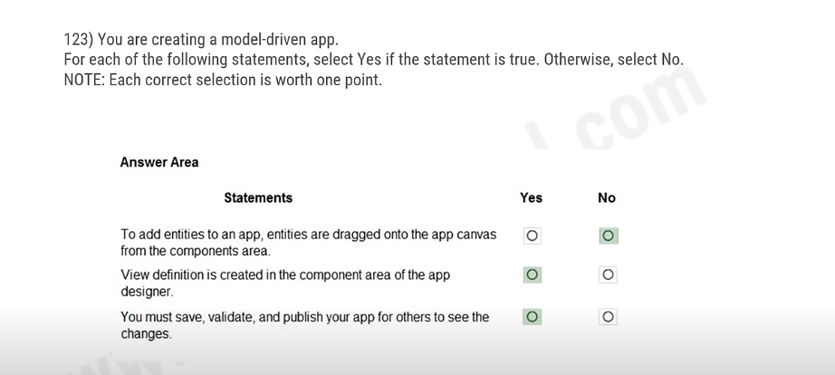

124) A security administrator is creating Power Apps security groups for the team and wants to ensure everyone has the permissions required for their roles without making any compromises. Which of the following is true about security groups within Power Apps?

A. Individual users can be assigned greater permissions the group itself

B. All users must have the same permissions level

C. Permissions in Power Apps carry over to Power BI

D. Power Apps security groups cannot share apps

126) A developer is comparing the Power Apps model-driven approach and canvas apps approach for app solutions. Which choices are the benefits of a model-driven Power App approach? (Choose 3 answers)

A. The user interface is consistent for both desktop and mobile users.

B. The no-code layout is consistent across all apps in the organization.

C. The app's rendering will automatically respond to the user's device.

D. Supports extensive Ul design flexibility and customization

130) A team lead manages the release of a new app that the team built in Power BI and needs to review which promotion stages the app can go through before being released publicly. Which stage in the app release management pane indicates the app is now available for testing publicly? For testing publicly?

A. Workspace

B. Testing

C. Pre-productions

D. Production

131) A developer is trying to build a Power Automate flow, but it's currently broken. The developer has placed actions that pull data from Dropbox before an action that emails team members the Dropbox data. What step does the developer need to complete to make his Power Automate flow functional?

A. Move the action that uses Dropbox outputs after the email action.

B. Create a new flow.

C. Trigger the flow from a different point.

D. Place the action that uses Dropbox outputs before the email action.

133) By utilizing_________ you can trigger Power BI data source refreshes based on source data changes and update the dataset using Power BI's API interface.

A. Power BI Desktop

B. PowerBl.com

C. ArcGIS

D. Microsoft Power Apps Flow

134) A developer is building conversation topics for Power Virtual Agent bots, and needs to identify opportunities in each conversation to obtain more detail using conditions. Which conversation node allows the developer to add a condition?

A. Ask a question

B. Call an action

C. Show a message

D. Go to another topic

136) A developer is designing a set of brand-new flows linked to content in Dataverse for the copilot studio bots Which of the following requirements must Michaela's flows meet to function in copilot studio? (Select three.)

A. The flow can only be called from a topic that lives in the same Dataverse environment as the bot.

B. The flow must also be a Power Automate solution.

C. The flow values must be returned synchronously to copilot studio

D. The flow must have been created from a Dataverse template.

137) Which three actions can a Power Platform Admin perform when managing application users? (Choose 3 answers)

A. Create an application user

B. Delete an application user

C. Edit the details of an application user

D. Assign new security roles to an application user

139) An IT manager needs to create and provision new production environments as a Power Platform administrator, but only holds a Microsoft 365 plan license. Which plan allows users to provision a new production environment?

A. Dynamics 365 plans

B. Dynamics 365 Team plans

C. Dynamics 365 Trials

D. Power Apps Developer plans

140) A data engineer has deployed a Finance and Operations environment and successfully integrated Microsoft Power Platform. He knows many ways to get his Power Platform apps to talk to the Finance and Operations apps and retrieve account information. Which event type should the data engineer configure if the engineer wants local app overlapping data raised is kept in sync to be stored.

A. Dual-write event

B. Data event

C. Visual entities

D. Business event

238) You complete development and testing of a new canvas app. You add users to a security team and assign the security team permissions to the app. Users are unable to view the app. You need to ensure that users can launch and use the app. What should you do?

A.Add the application to the solution.

B.Publish the application.

C. Share the application.

D. Add a Power Apps Component Framework (PCF) control to the application.

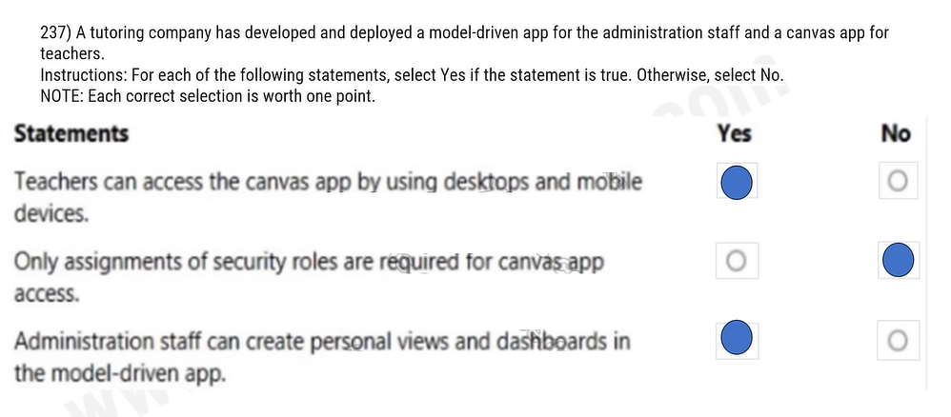

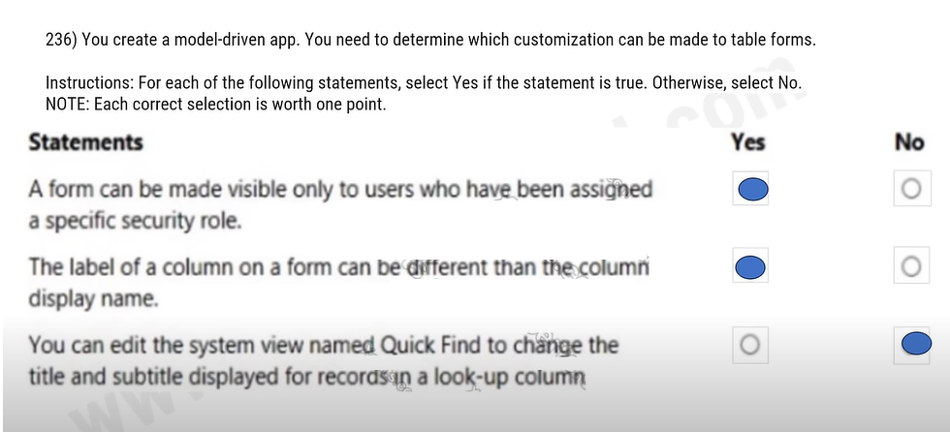

235) You create a model-driven app for a department.

You need to make the model-driven app available to other department members. Which two methods should you use? Each correct answer presents a complete solution.

NOTE: Each correct selection is worth one point.

A. Send the application's Web URL to other team members by email.

B. Use the Share feature in the Power Apps designer.

C.Publish the app to AppSource.

D.Deploy the application to other user's instances through PowerShell

234) A Power Apps developer has sufficient permissions to create apps, connections, and flows. The developer does not have permissions needed to access company data. You need to grant the developer access to company data for an app. Which predefined security role should you assign to the developer?

A. Environment Maker

B. System Customizer

C. Common Data Service User

D. Delegate

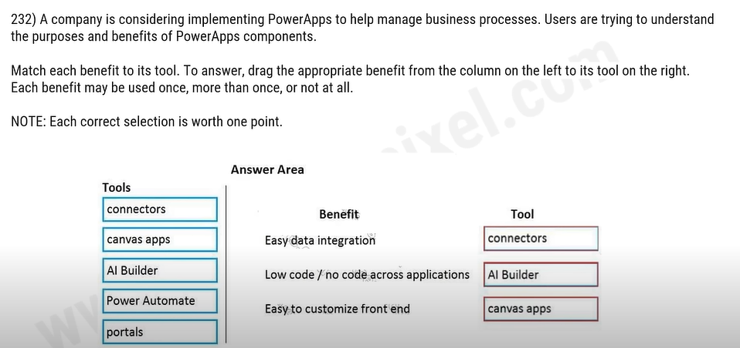

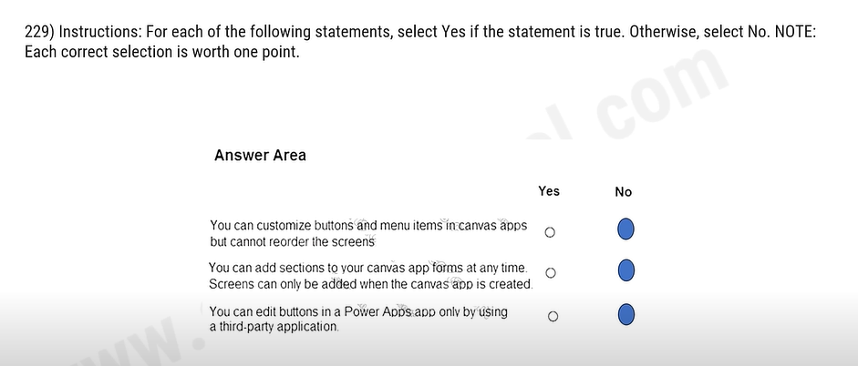

228) For each of the following statements, select Yes if the statement is true. Otherwise, select No.

NOTE: Each correct selection is worth one point.

You can embed a canvas app in a Microsoft Forms form to collect user feedback. No

You can embed a canvas app within a Microsoft Excel worksheet to allow users to interact with data in a structured way NO

You can embed a canvas app within a Power Platform model-driven app YES

227) A company uses a model-driven app for their mobile sales activities.

The company wants to modify the view that is used for sales orders. You must apply a new default filter to the view. You must also modify the default sorting for sales orders. You need to make the changes to the view.

In which three locations can you make the changes? Each correct answer presents a complete solution. NOTE: Each correct selection is worth one point.

A. Power Apps site

B. Solution Explorer

C. Microsoft Azure DevOps

D. App Designer

226) A company uses Microsoft 365, Power Platform, and Dynamics 365. You do not assign permissions to any licensed users. Users are able to create and edit Power Apps canvas apps. In which environment are users creating and editing the apps?

A. Production

B. Default

C. Sandbox

225) You create a Power Apps canvas app. You need to ensure that your coworkers can run the app. What should you do?

A. Share the app.

B. Send the URL for the app to coworkers.

C. Publish the app.

D. Create a Flow for the app.

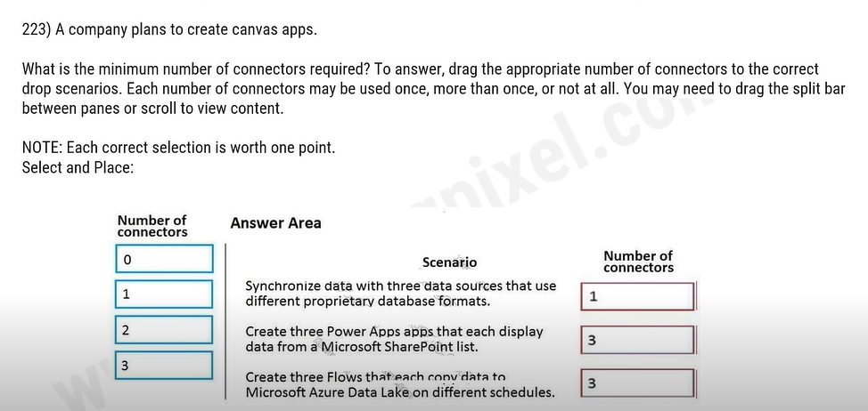

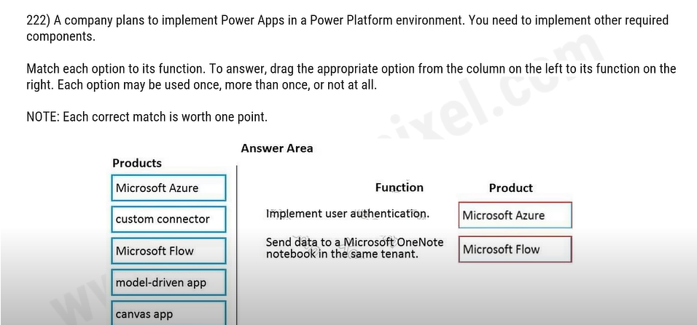

221) A company plans to create a canvas app that connects to three databases with different proprietary database formats. What is the minimum number of connectors required?

A.0

B.1

C.2

D.3

220) A company has a Power Apps app that is used by most employees. The company is expanding to other countries/regions. You need to recommend a solution to translate text generated within the Power Apps app in near real-time. What should you recommend?

A. Microsoft Azure Synapse Analytics

B. Microsoft Azure Cognitive Services

C. Common Data Service connector

D. Power BI

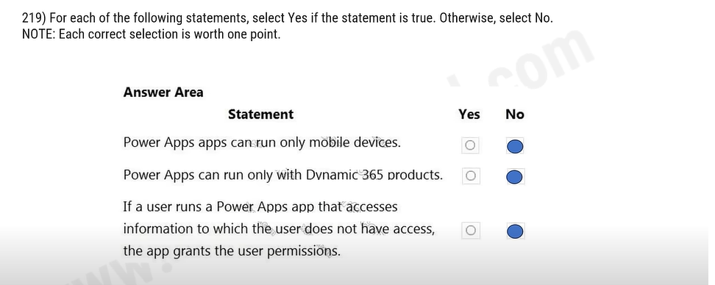

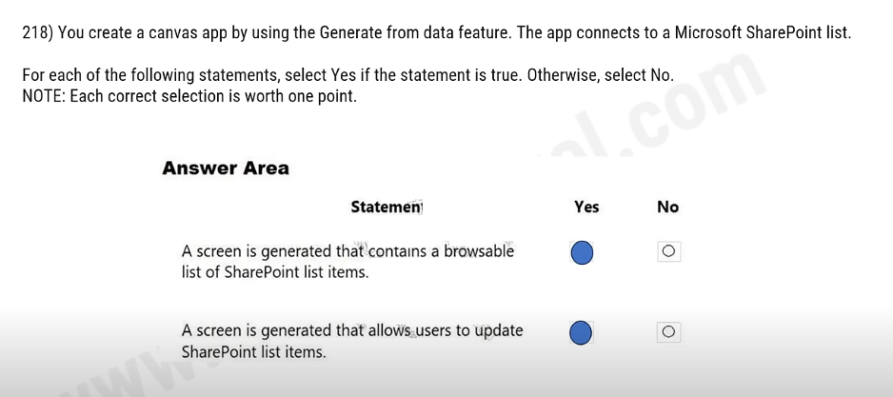

217) You have a Microsoft Excel workbook that contains a list of tasks for a project. You store the file in OneDrive for Business. You need to create a canvas app that allows team members to update the status of their tasks. What should you use?

A. the Generate an app from data feature

B. a custom action in Common Data Service

C. Power Apps Checker

D. the Open entity data in Excel feature

215) You create a canvas app that allows contractors to submit time they work against a project.

Contractors must be able to use the canvas app to enter time.

Contractors must not be able to perform any other actions in the app.

You need to configure permissions for the contractors. Which type of permissions you use?

A. application-level

B. task-level

C. record-level

D. field-level

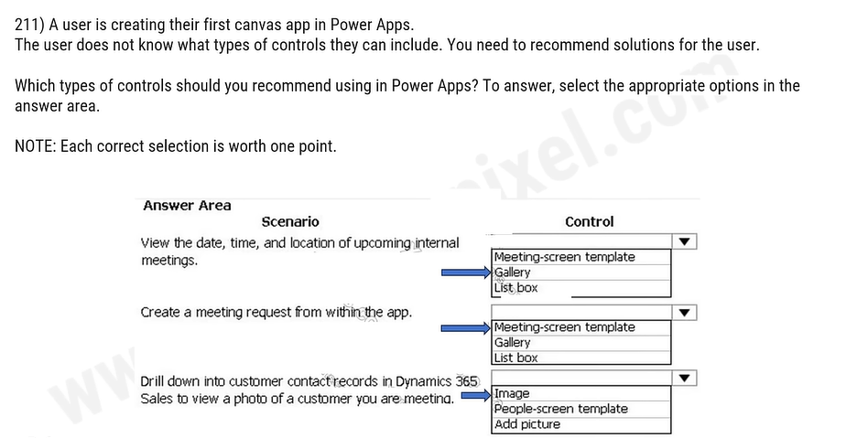

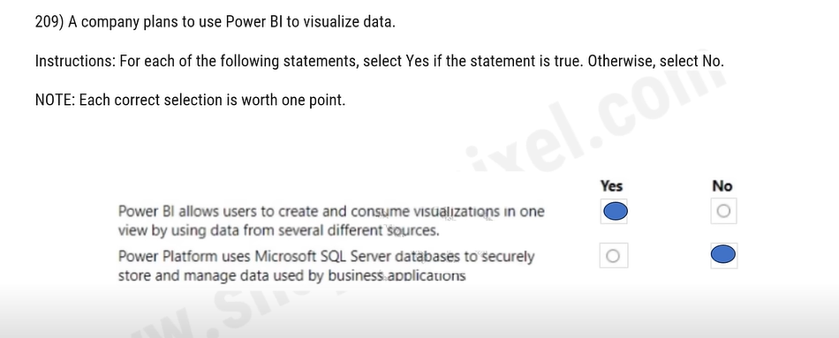

208) You are developing a Microsoft Power Platform solution. The solution uses data stored in Microsoft Excel, a Microsoft Dataverse database, and an Azure SQL database.

You must create several visuals to enable the data to display on a screen without moving the data out of its source location.

You need to create the visuals.

Which tool should you use?

A. Power Automate

B. Power Platform Center of Excellence Starter Kit

C. Power Virtual Agents

D. Power BI

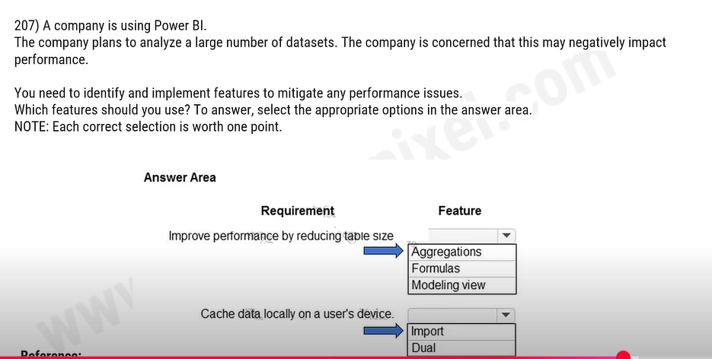

206) A company is using Power Bl.

The company wants to see which data connectors are available for building dashboards. You need to evaluate the available connectors.

What should you use to see all the available connectors?

A. Power BI Workspace

B. Common Data Service

C. Power BI Dataflows

D. Power Platform admin center

E. Power BI Desktop

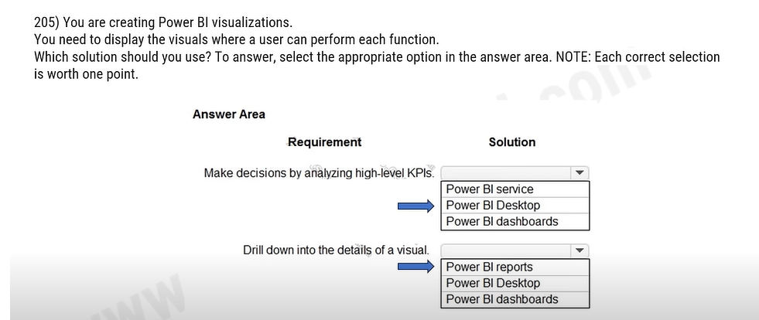

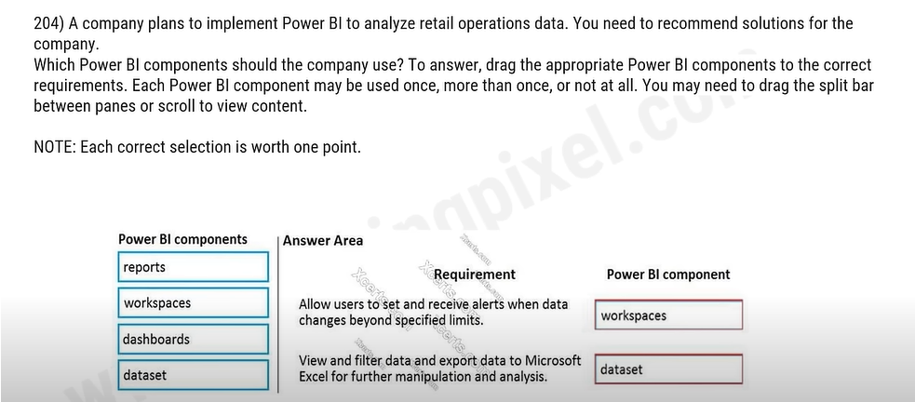

203) What is a benefit of deploying Microsoft 365 and Dynamics 365 apps in the same tenant?

A. You do not need to manually back up data.

B. Both will use the same time zone.

C. You can use Power BI to display data that comes from both environments.

D. You can implement Single Sign-On (SSO).

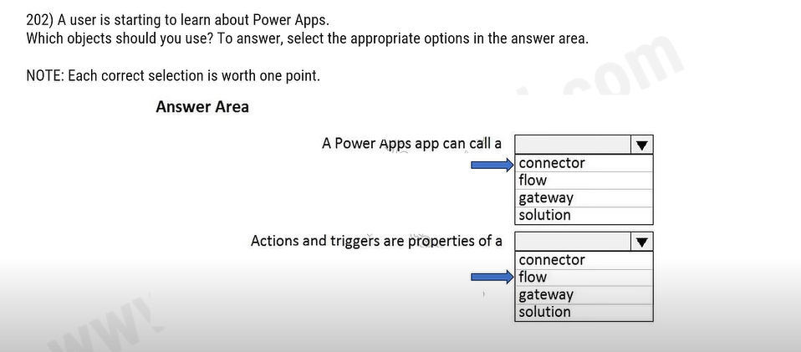

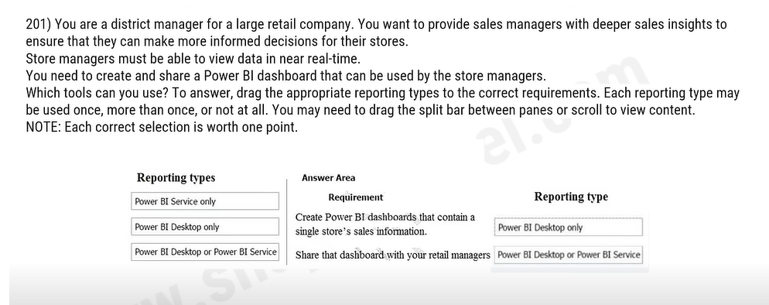

200) A recent update has been made to a canvas app. The update causes a negative impact to users.

You need to roll back the app to a previous version. What should you do?

1. Restore the previous version of the app.

B. Uninstall the app for all users and reinstall by using the package from a previous version.

C. Deactivate the live app, import the previous version of the app, and then activate the app.

D. Delete the app and create a new app based on the previous version.